Department of Data Science
Faculty of Computing and Information Technology

University of the Punjab


Sheet No.:
Invigilator Sign:
Date: 31-07-2024

BSDS Fall 2021

Mid term Examination– July 2024

Student ID: | Student Name:
Shift / Section: Morning / Afternoon | Student Signature:

Course Code: DS-306 Course Title: Data Warehousing & Business Intelligence

Maximum Time: 90 Minutes Maximum Marks: 61

Instructions

- Read questions carefully before attempting
- Attempt all questions on the answer sheet
- Paper has 7 pages, including cover sheet
- If there is any ambiguity in the paper, benefit will be given to the students
- Understanding is part of examination, therefore no query will be entertained during exam

Questions | 1 | 2 | 3 | 4 | 5 | Total
Total Marks
Marks Obtained

Examiner Signature: Marks out of 35:
DO NOT OPEN UNTIL YOU ARE TOLD TO DO SO

Q1. Answer the following multiple-choice questions. Write the correct options in the table at the end of this question (10 marks).

- Which of the following is not included in a metamodel _______________.
        - All modeling concepts
        - Relationship between concepts
        - Modeling notations
        - All of the above

- Decision-making requires _______ for decision support.
        - Complex queries
        - Integrated data
        - Enterprise-wide view
        - All of the above

- _______ property of data warehouse refers to inability of data to be updated.
        - Subject oriented
        - Time variant
        - Non-volatile
        - Integrated

- Time dimension is the ______________ part of a dimension schema.
        - Non-necessary
        - Optional
        - Both of the above
        - None of the above

- A dimensional model may be composed of ______________.
        - One fact table and set of dimension tables
        - Multiple fact tables and set of dimension tables
        - Association between dimension and fact tables
        - All of the above

- Which of the following is not modeled in dimension model.
        - Level
        - Hierarchy
        - Cardinality
        - Entity

- In the dimensional model, two levels having one-to-one relationship between each other, and the lower level have having one-to-one relationship with fact table. It will be changed to ________ table or tables in logical model.
        - One table
        - Two tables
        - Three tables
        - None of the above

- _____ schema is the type of DW design in which there is more than one measures.
        - Start schema
        - Snowflake schema
        - Constellation
        - All of the above

- Surrogate key provides ______________.
        - Independence from underlying source keys
        - ability to handle type two changes
        - Both of the above
        - None of the above

- ______ hierarchy has branches having the same length.
        - Generalized hierarchy
        - Unbalanced hierarchies
        - Both of the above
        - None of the above

Please fill the answers of the MCQs in the following table.

MCQ # | Correct Option | MCQ # | Correct Option
1. |  | 5.
2. |  | 6.
3. |  | 7.
4. |  | 8.
9. |  | 10.

Q2. Briefly, answer the following short questions. 3 Marks for each question (21 marks)

- What are the main differences between dependent data marts and independent data marts

- Write one advantage and one disadvantage of Star Schema. Also, write one advantage and one disadvantage of the Snowflake Schema?

- Draw the metamodel of constellation schema?

- If a level is related to fact table in the conceptual model. How should it be modeled in a logical model so as to manage all three types of changes to data?

- Explain why dimensional model is more useful than Entity relationship model.

- Distinguish between the following types of data sources. Internal data, external data and production data.

- Distinguish between Slowly and rapidly changing dimensions.

Q3. Convert the following Star Schema into a fully normalized Snowflake scheme. (10 marks)

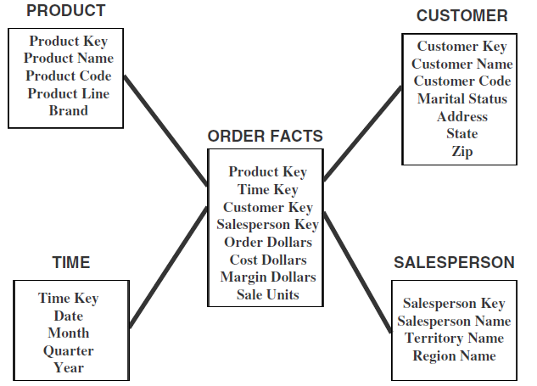

Q4. Convert the following conceptual schema into Logical Model. (10 marks)

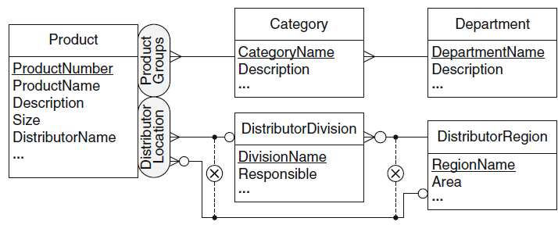

Q5. The three types of changes in a dimensional model are, type 1 changes: correction of errors, Type 2 changes: History preservation, Type 3 changes: Tentative revisions. Discuss and give example of Type 2 and Type 3 Changes. (5+5 marks)

